Chapter 11, Problem 56.

Obtain the complex power delivered by the source in the circuit of Fig. 11.75.

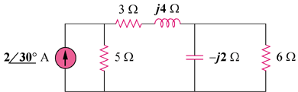

Figure 11.75
For Prob. 11.56.

